Generate signed apk guide:

1. Navigate to Build -> Generate Signed APK

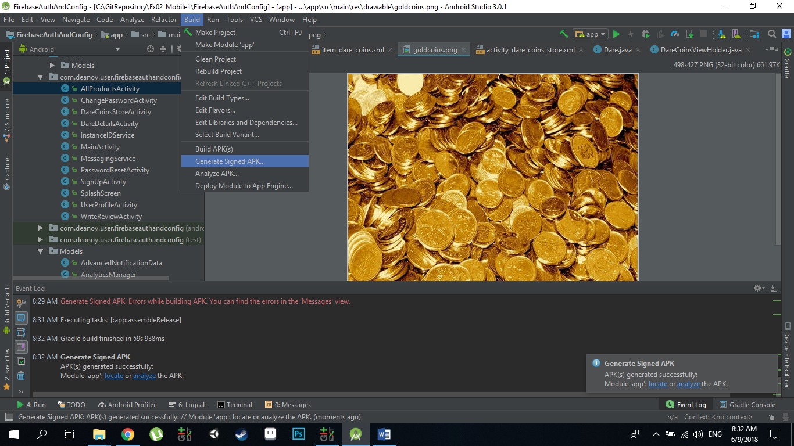

1. The following windows will pop up. If you already have done this process before, the last generated key details will appear. If you want to continue with the last key – enter the key store password and the key password ( in our case the password is Aa123456 at both cases) and then press next and continue to step 5 at this guide .

If you want to generate new key- click on create new.

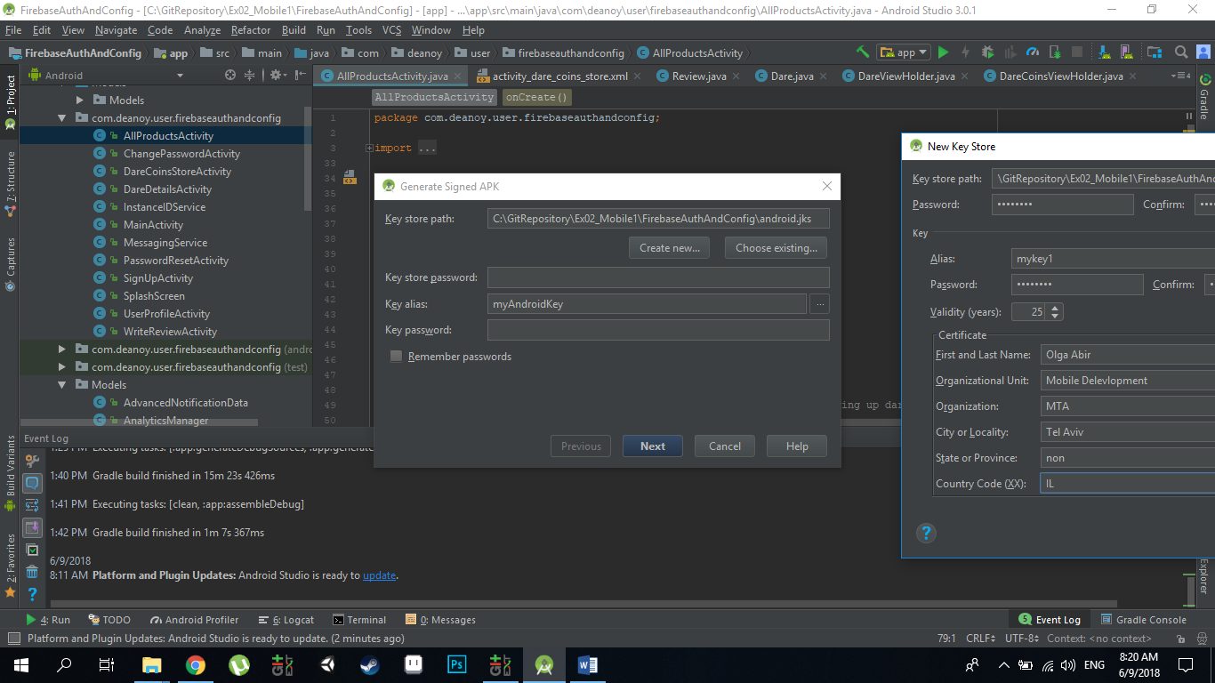

1. This window will pop up. At the Key store path navigate to your project path :

in my computer it was :

C:\ GitRepository\Ex02_Mobile1\FirebaseAuthAndConfig\

After that, add to the path the wanted name of the key , for example in my case:

C:\ GitRepository\Ex02_Mobile1\FirebaseAuthAndConfig\android1.jks

Then fill in all the remained fields and press ok.

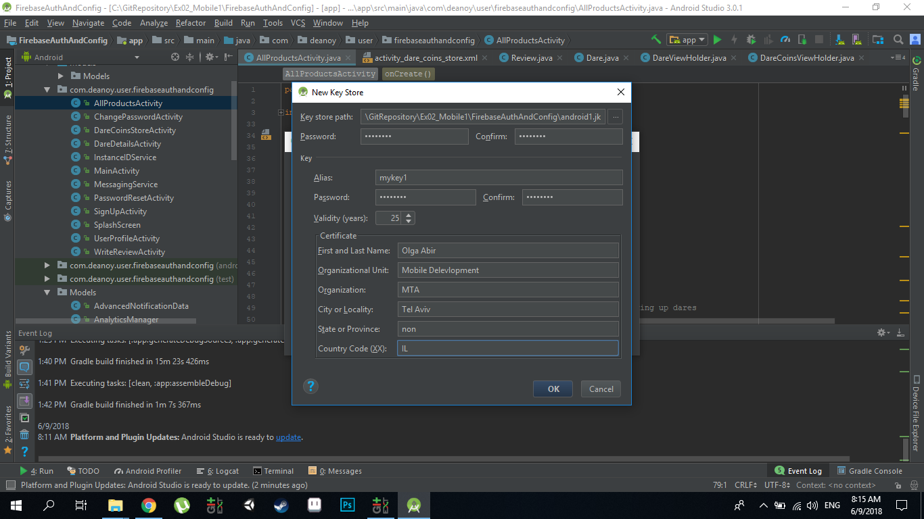

1. Now you have this windows with the details from the create new window already entered,

Press next.

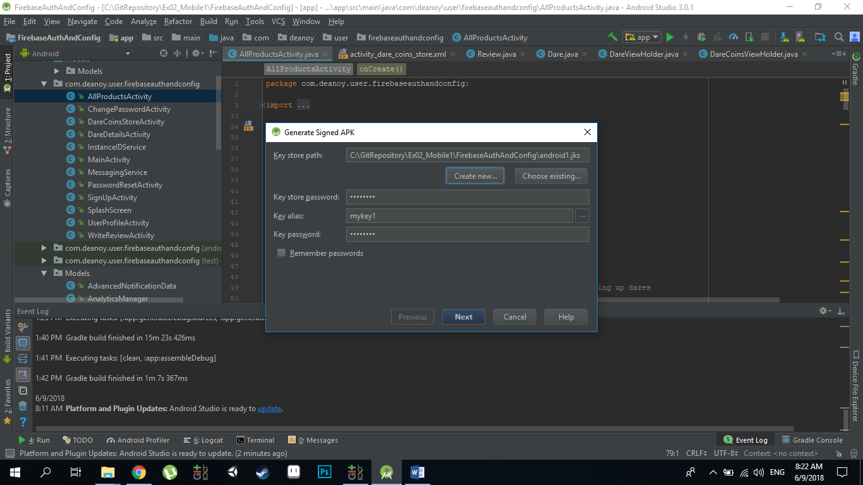

1. At this window check the V2 version and click finish.

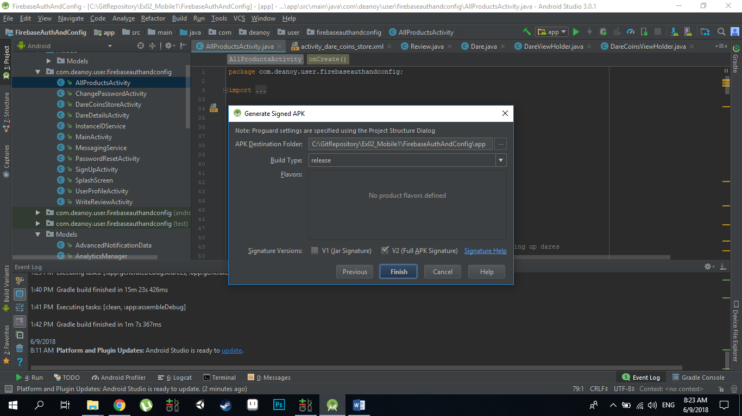After you click finish it will start to build. Usually this process fails because of problems with drawable files. You can fix it easily and then go again through this guide steps – you can continue with the same key, just enter his password at step 2. When the build process that generated after you click finish at this window is successfully done- the key is ready for use.